ANCIENT CIVILIZATIONS - INTRODUCTION
Instructions – Fill in the blanks with the words below from the video
archaeologists domesticate written hunted specialize gathered Mesopotamia differently prehistoric cities trade agriculture civilization technology crops writing
_________________________________________________________________________________________
Thousands of thousands of years ago people lived ____________ than they did today. They _________ and _____________. There is no ______________ record. That makes them _______________. _______________ are scientists that study humans in the past. Paleontologists are responsible for the fossil record. Society changed when people started to grow ___________ and _______________ animals like cows, chickens and goats. _______________ allowed people to stay in one place. More and more people lived together and people were able to ____________________, or do 1 kind of work. ___________ developed among all the specialists.
As society developed, __________________ allowed people to do more, and grow more and towns turned to ______________. ______________ developed as a way to keep track of trade, and eventually pictographs became symbols and sounds and words. A group with a similar culture and characteristics is known as a ________________________. The first civilization developed in ____________________________.
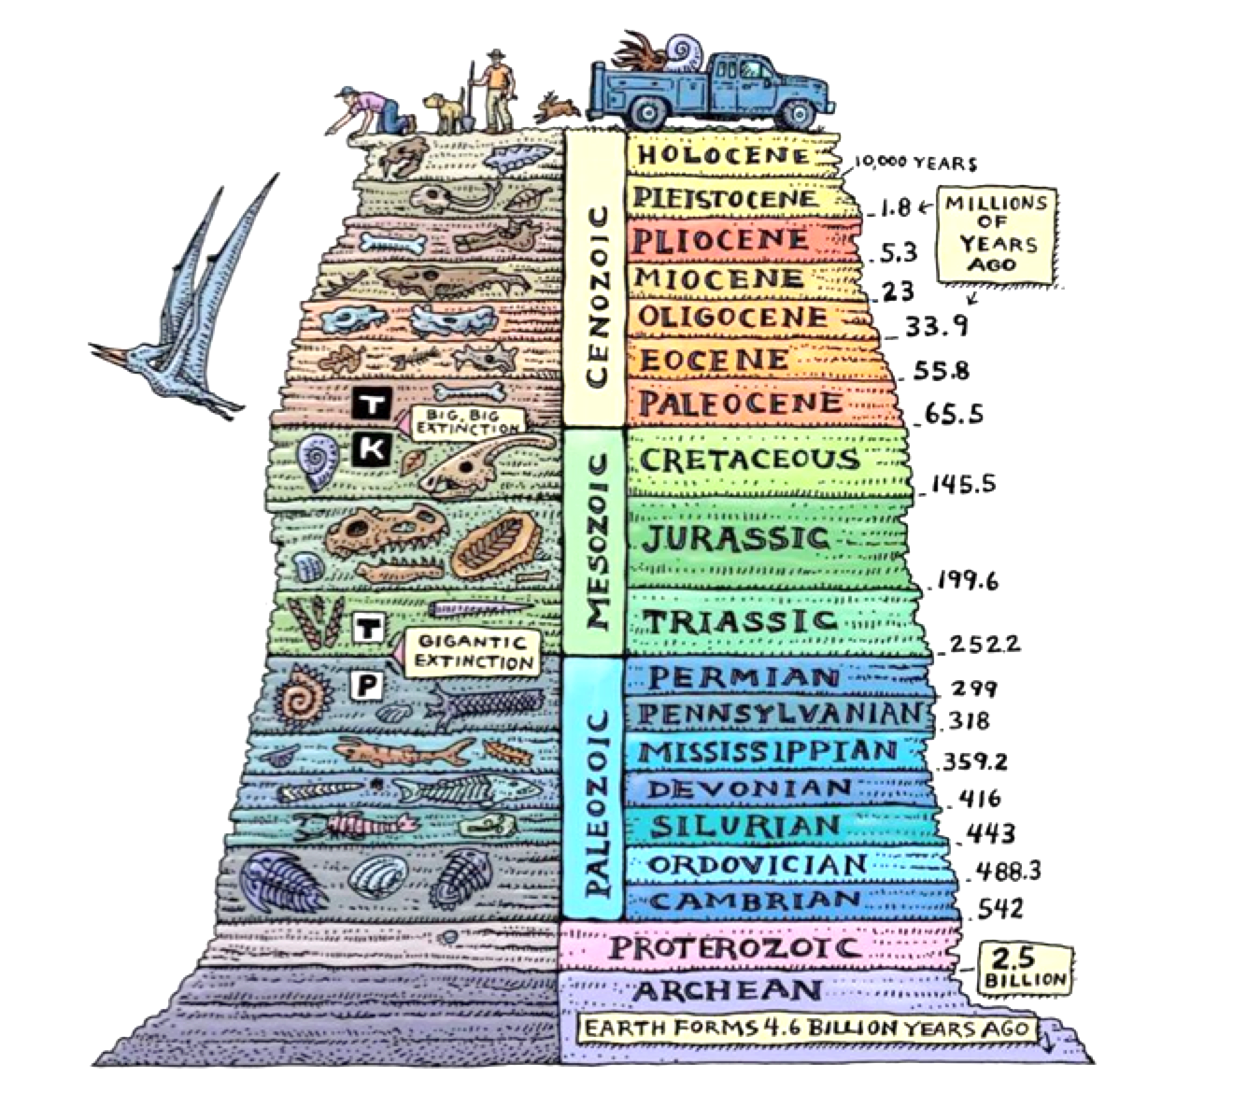
THE FOSSIL RECORD

